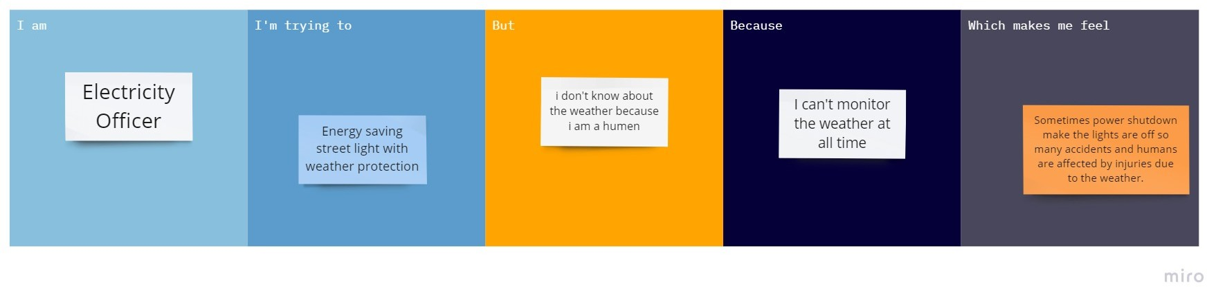

Currently we are facing more healthy issues.

Main healthy hygienic life style.

Public

A lot of death’s caused by the Health issues which are affected by Bacteria…

Due to some bacteria created in Restroom.